SAP UI-Plant Search Help

General

|  |  |
| --- | --- |
| Type of Object | **SAP Gateway Service** |
| **Description** | Create Gateway service to implement custom Plant Search Help based on Company Code as an input |
| **Process** | P2P |
| **Sub Process** | N/A |

DOCUMENT ORIGIN

|  |  |
| --- | --- |
| AUTHOR | OPERATION UNIT |
| Goutam Roy | SAP – APPS TWO |
|  |  |

CHANGE HISTORY

|  |  |  |
| --- | --- | --- |
| VERSION | DATE | CHANGES |
| 1.0 | 29-JUL-2016 | Initial version |
|  |  |  |
|  |  |  |
|  |  |  |
|  |  |  |

REVIEW AND APPROVAL

|  |  |  |  |  |
| --- | --- | --- | --- | --- |
| COMPANY | NAME | ROLE | DATE | SIGNATURE |
| Capgemini India Pvt. Ltd. | Suprio Chatterjee | Mentor | 23.08.2016 |  |
|  |  |  |  |  |
|  |  |  |  |  |
|  |  |  |  |  |
|  |  |  |  |  |

# Introduction

## Document Purpose

This document describes how to create ‘ABAP Gateway Service’ for search help of ‘Plant (WERKS)’ based on ‘Company code (BUKRS)’ as input parameter.

# MAJOR FEATURES

Here the document describes the process step by step with screen shot to create ‘ABAP Gateway Service’ for search help of ‘Plant (WERKS)’ based on ‘Company code (BUKRS)’ as input parameter.

# TECHNICAL DETAILs:

## [Step](http://help.sap.com/saphelp_ewm70/helpdata/en/74/d67237902ae147e10000009b38f842/content.htm) by Step process to create Gateway service

**Step-1:** Create RFC function Module which will return all the plant details for the company code as input parameter. This RFC Function Module will be used in the gateway service creation.

Below is the code of the RFC Function Module



**Step-2**

Go to Transaction code **SEGW** to open the Gateway Service Builder

**Step-3**

Click on the **Create project** button

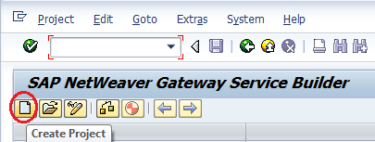

**Step-4**

Enter the **project name** and **description** and click on the **continue** button

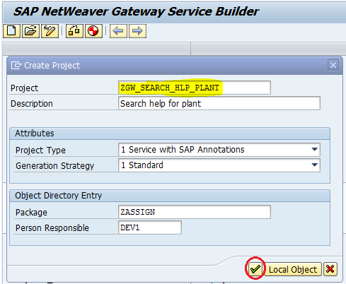

**Step-5**

Right click on the ‘**Data Model’** and click on the menu ‘**Import🡪 RFC/BOR Interface’** to create Entity Type and Entity Set by referring the RFC Function Module

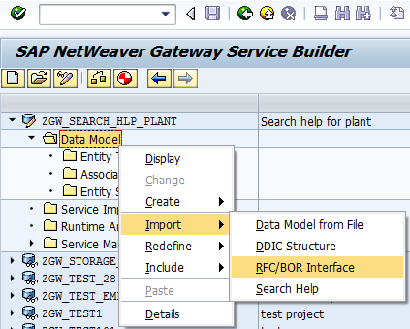

One popup wizard will open where enter the ‘**Entity type name’**, data source attributes type as ‘**Remote Function Call**’ and **Name of the RFC function module** and click on the ‘Next’ button

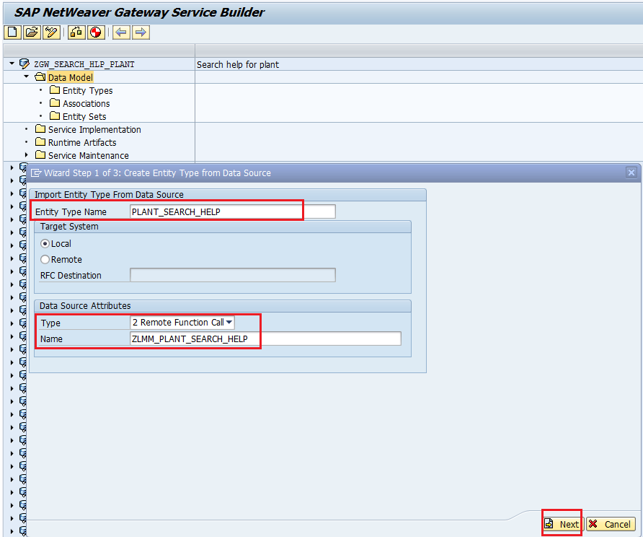

**Step-6**

Select all check boxes and click on the ‘next’ button

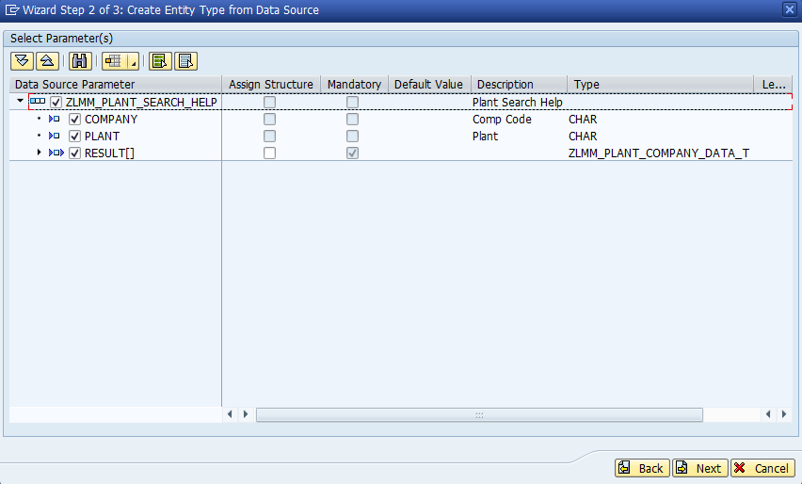

**Step-7**

Tick the key field in the ‘**Is Key’** column and also Tick the check box ‘**Create Default Entity Set’** and click the ‘**Finish’** button

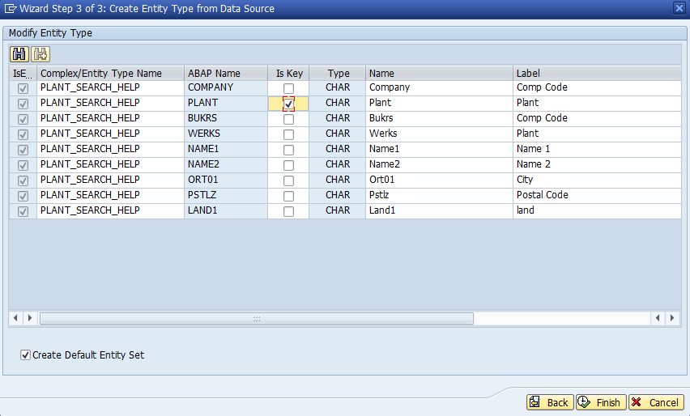

The ‘Entity Types’ and ‘Entity Sets’ will be created as below

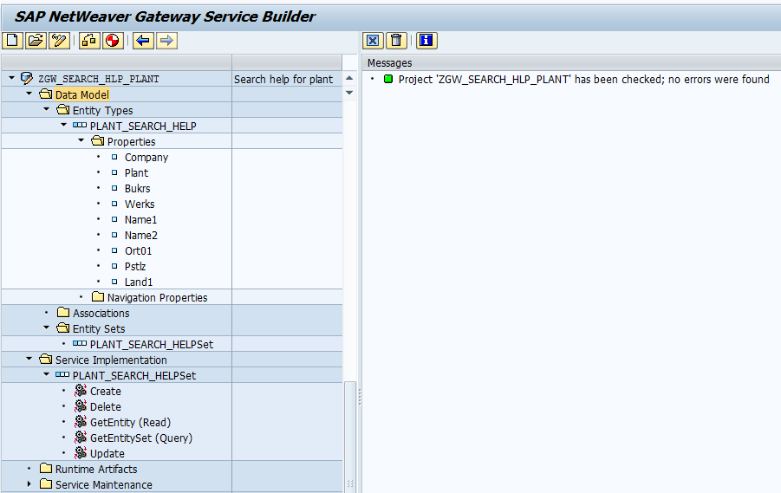

Double click on the ‘Entity Types’ properties and make the company code as filterable

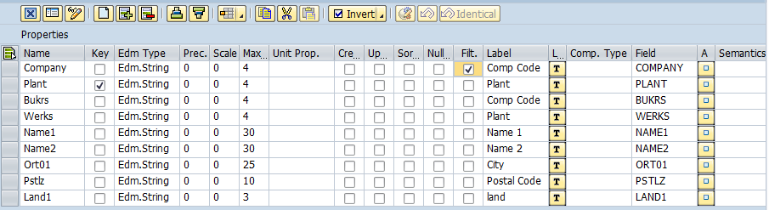

**Step-8**

Now **Right click** on the ‘GetEntitySet (Query)’ and choose ‘**Map to Data Source**‘

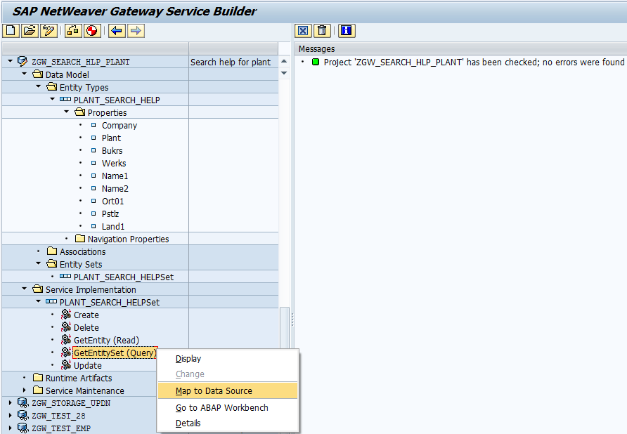

One popup will appear there enter the RFC Function Module Name and click on the continue button

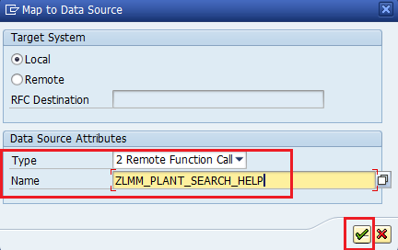

**Step-9**

Click on the ‘**Propose Mapping’** button to map the Gateway service parameter with the RFC Function Module

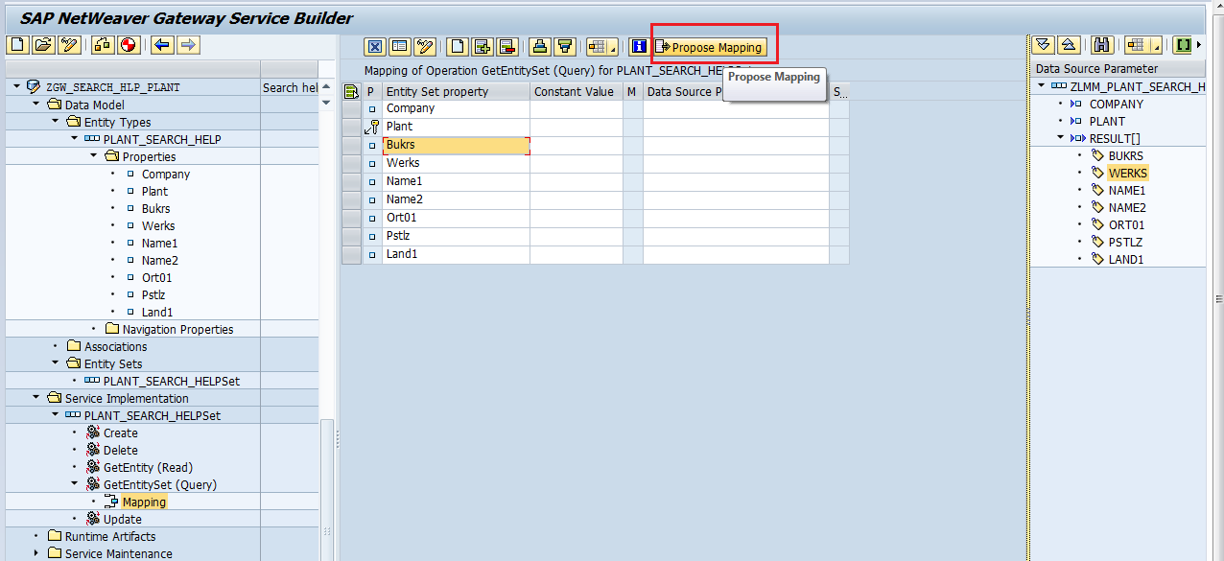

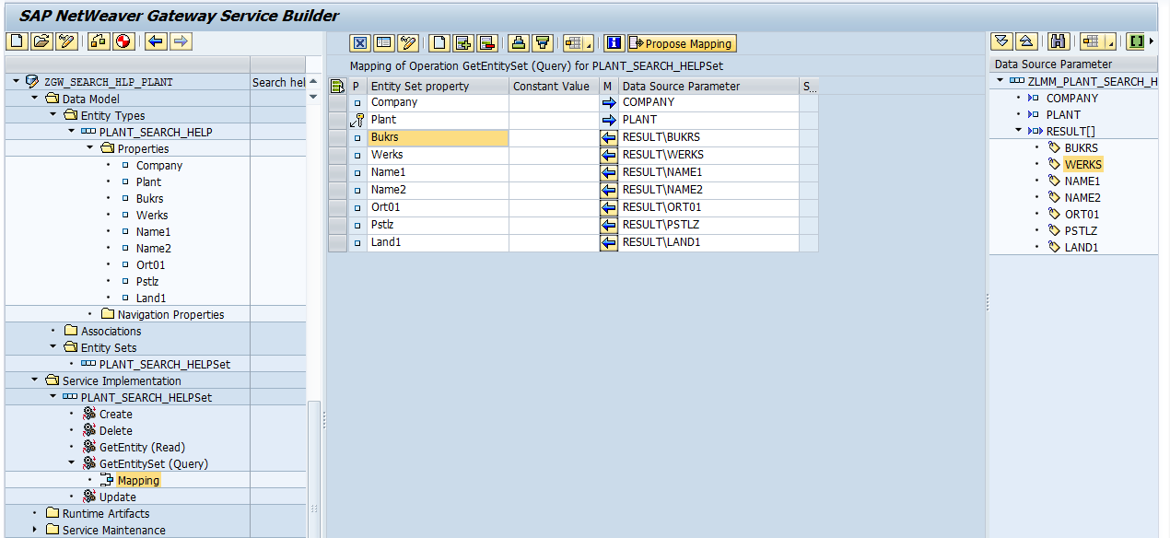

**Step-10**

Now click on the ‘Generate Runtime Services’  button

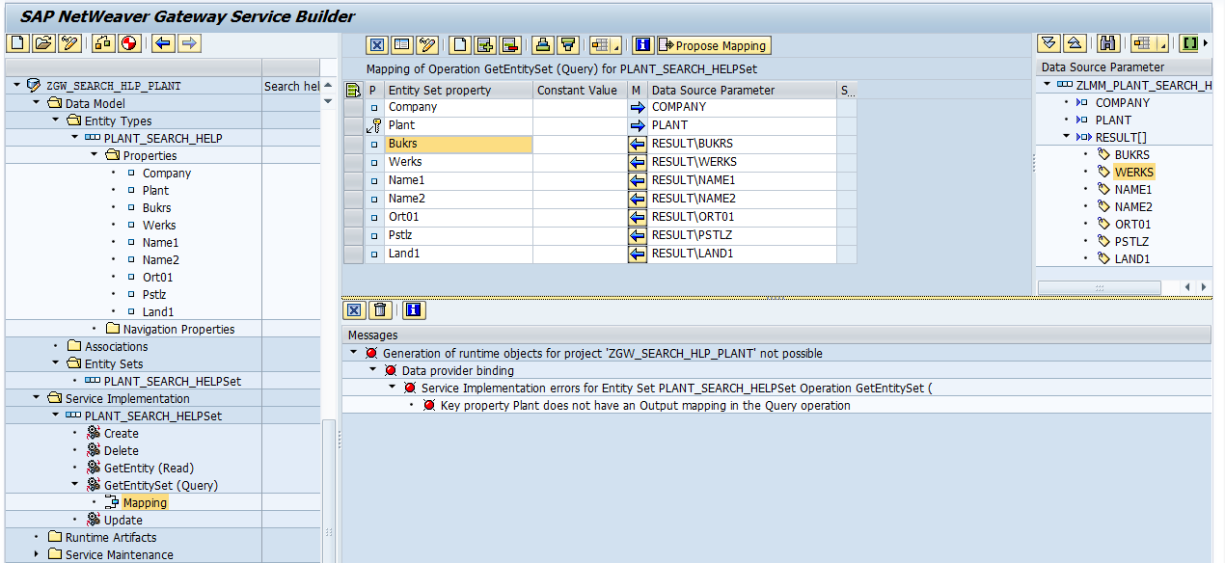

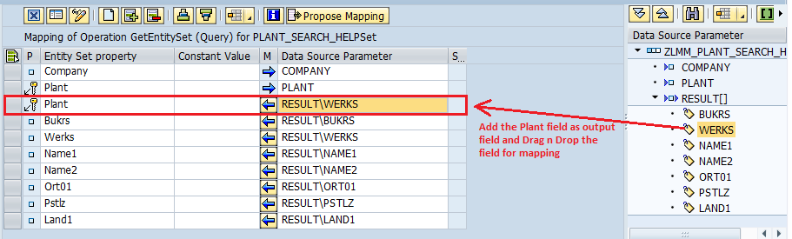

**Step-11**

Now click on the ‘Generate Runtime Services’  button

One popup will appear with ‘Model Provider Class’, ‘Data Provider Class’, ‘Technical Model Name’ and ‘Technical Service Name’. Here click the ‘continue’ button

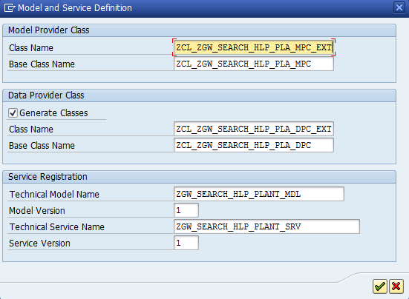

After click the continue button Gateway Service will be generated

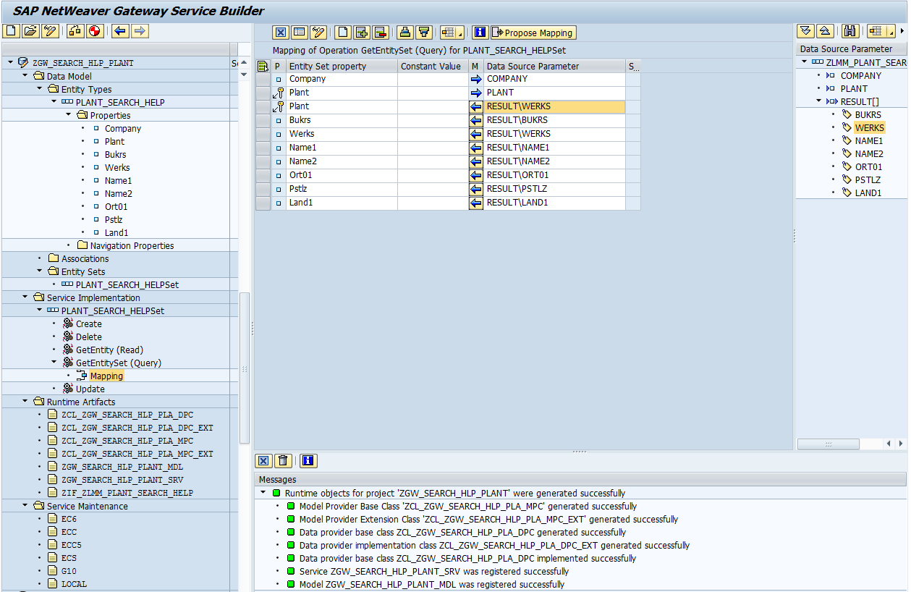

**Step-12**

Expand the ‘**Service Maintenance’** and Double click on the ‘LOCAL’ and click on the ‘**Register’** button  and enter the system where to register and run the Gateway service

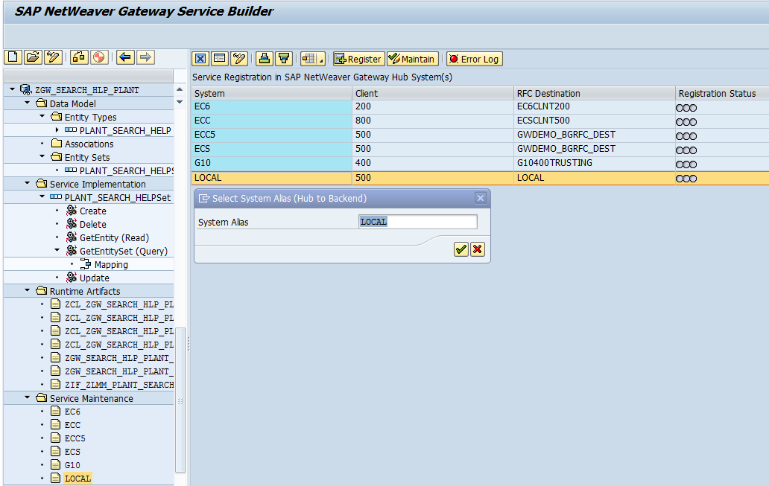

Enter the **package name** and click on the **continue** button

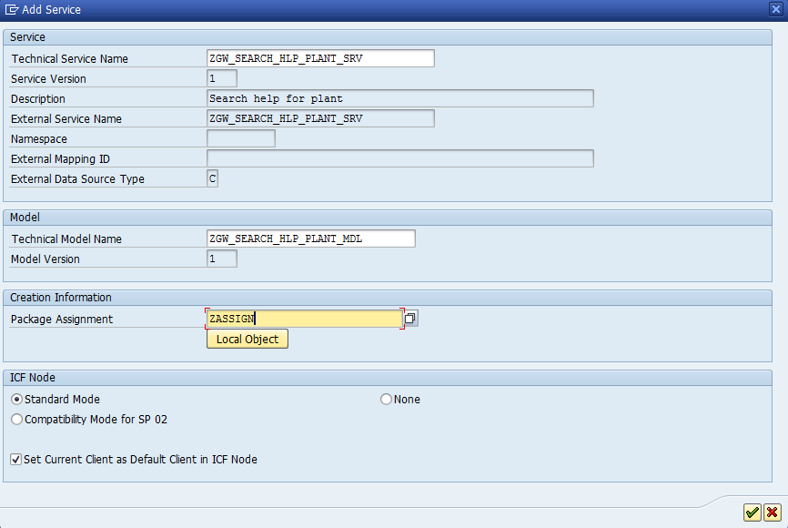

**Step-13**

Now click on the  ‘Maintain’ button to test the gateway service and get the URI of the service

One popup will appear there choose the ‘Yes’ button

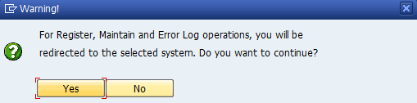

Now click on the ‘Gateway Client’ button 

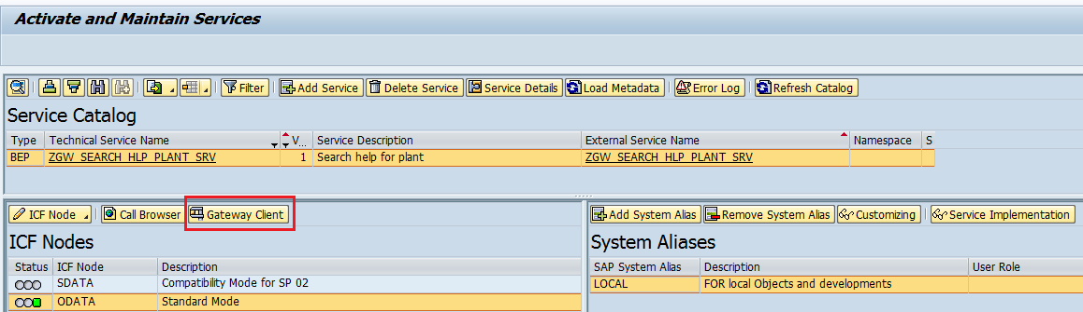

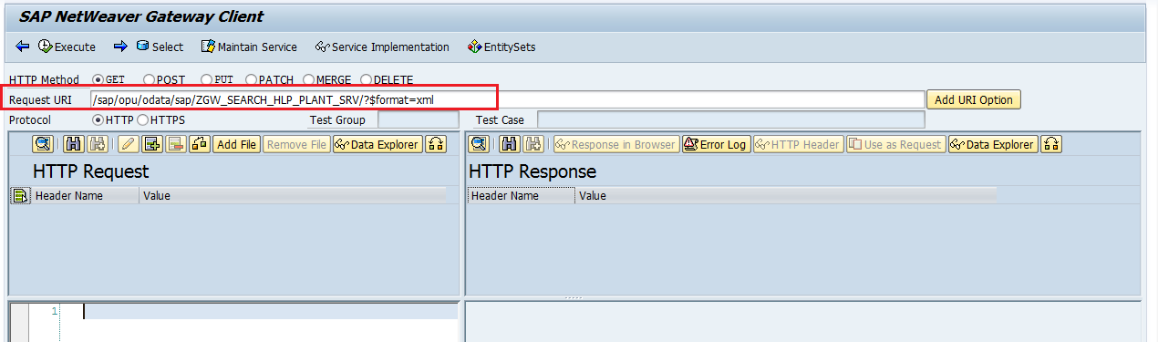

**Change the URI**: instead of ‘$format=xml’ in the URI enter ‘$metadata’ and execute to get the metadata

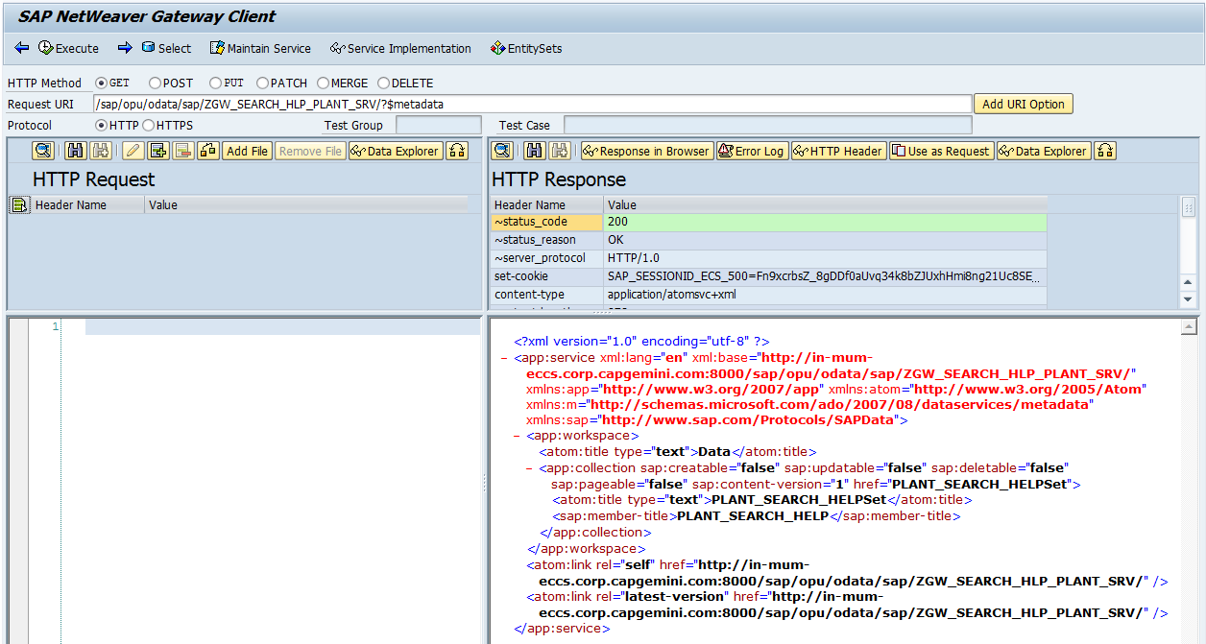

To get the parameterized query result, change the URI as below:

/sap/opu/odata/sap/ZGW_SEARCH_HLP_PLANT_SRV/PLANT_SEARCH_HELPSet?$filter=Company eq '1000'

Where **‘PLANT_SEARCH_HELPSet’** is the Entity Set Name and ‘**Company’** is the filter parameter and ‘1000’ is the value of company code

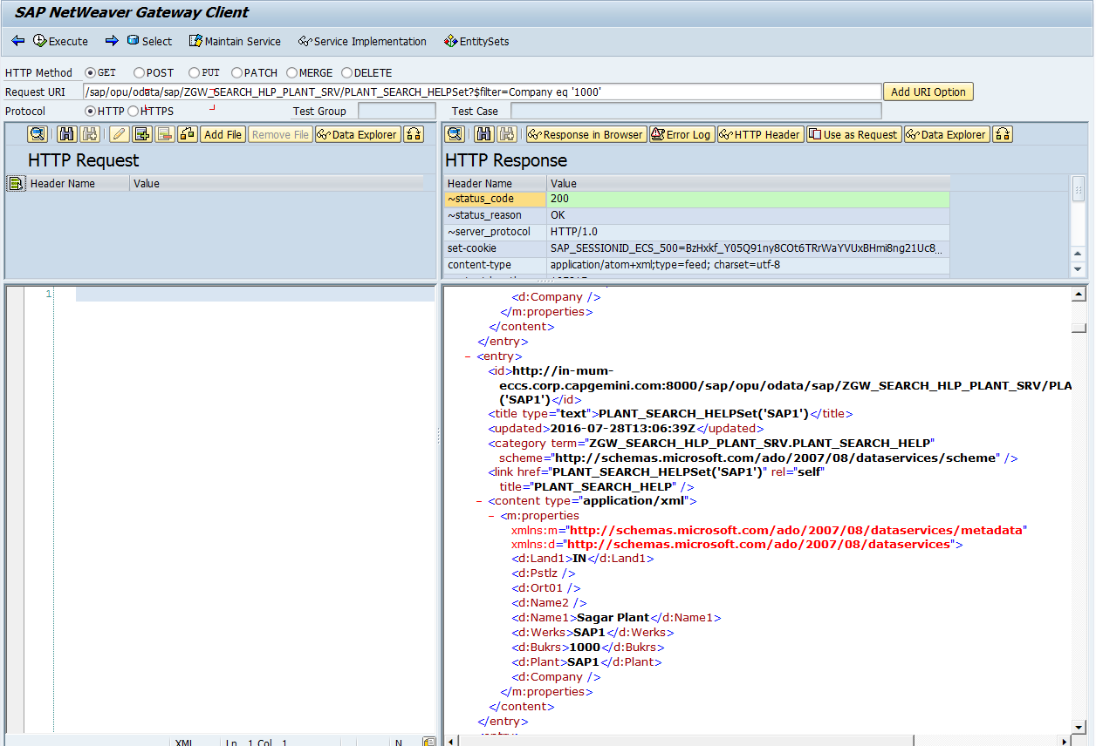

# UNIT TEST CASE

As mentioned above